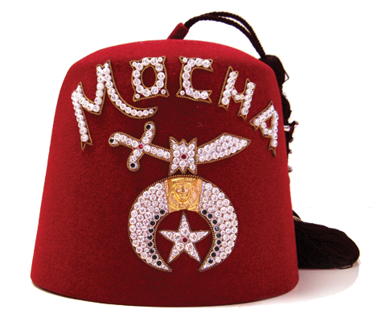
PETITION FOR INITIATION AND MEMBERSHIP
MOCHA SHRINERS
ANCIENT ARABIC ORDER OF THE NOBLES OF THE MYSTIC SHRINE
TO THE POTENTATE, OFFICERS AND NOBLE OF MOCHA TEMPLE, SITUATED IN THE OASIS OF LONDON, DESERT OF SOUTH WESTERN ONTARIO:

I, the undersigned, hereby declare that I am a Master Mason in good standing in ____________________ Lodge #________ located at____________________,______
City Province
Which is a Lodge recognized by or in amity with the Conference of Grand Masters of North America. Furthermore, I have resided at my current address for not less than six months, as required by the Bylaws of the Imperial Council. I respectfully pray that I may be made a Noble of the Mystic Shrine, and become a member of your temple.

Print Full Name_________________________________________________________
Name In Full - Initials not sufficient - please print clearly

Birthplace_________________________________ Date of Birth M_____D___Y______

Have you previously applied for admission to any temple of the Order?______________
If yes, what Temple? ________________________When?_______________________

Profession or Occupation_________________________________________________

Residence Address______________________________________________________
Street City
_____________________________________________________
Province Postal Code Home Telephone

Mailing Address ______________________________________________________
Street City
_____________________________________________________
Province Postal Code Home Telephone

Business Address _____________________________________________________
Street City
_______________________________________________________
Province Postal Code Business Telephone

Email Address_____________________________________ Fez Size _____________

Partner’s Name________________________________________________________

Date _____________ 20____ Signature____________________________________

Recommended and vouched for on the Honour of Noble

Noble ________________________________________________________________
Print Name Signature City Membership #

Noble ________________________________________________________________
Print Name Signature City Membership #

